Voicemail Greeting Setup

Method 1: Desktop Recording
Press the Windows key on your keyboard, type “Voice Recorder”, and then hit enter.
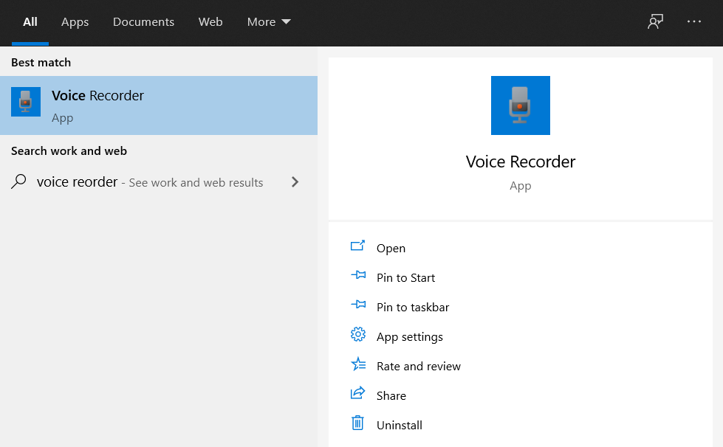
Use this app to record your personal voicemail greeting(s).
After recording, select the recording(s) that you plan to use and rename appropriately.
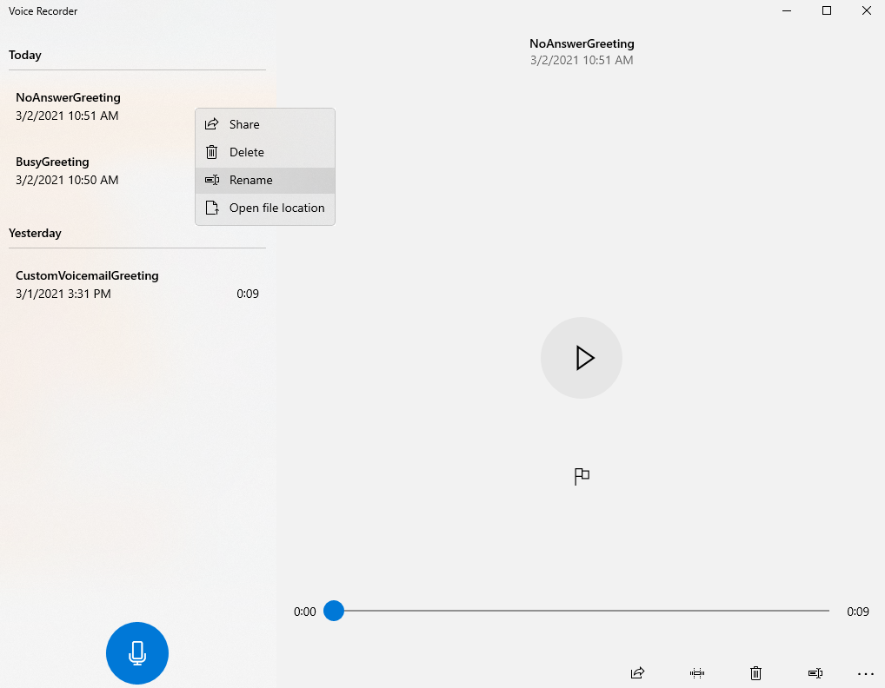
Next, open your browser and go to https://g711.org
Click on Browse
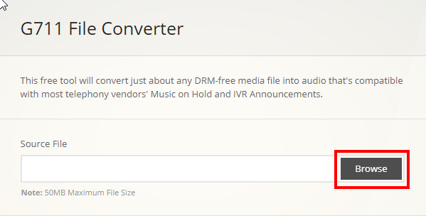
Navigate to Documents > Sound recordings
Select one of your recordings.
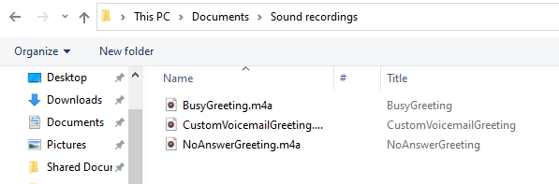
Click on Submit at the bottom of the Web page.
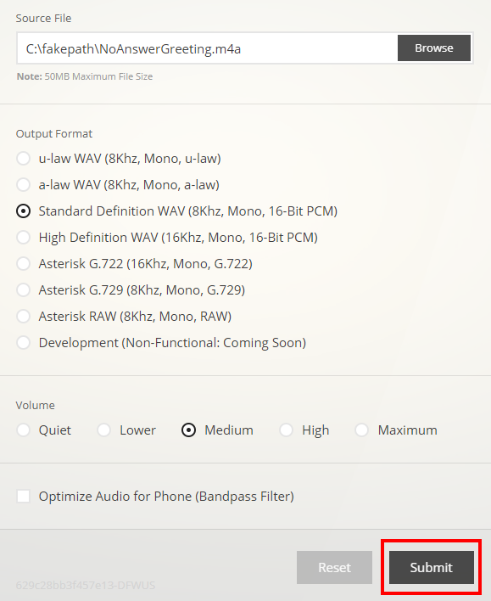
Click on the link to download the converted recording.
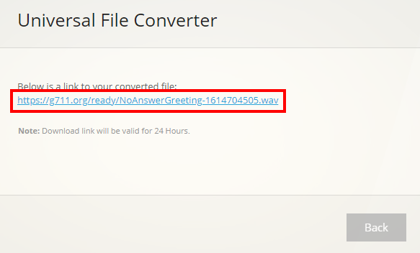
Click on back and repeat the process for the remaining recordings, if any.
Next, in your browser, navigate to access https://myvoice-1a.vonage.com/manualLogin.jsp
Login using your MobileConnect credentials.
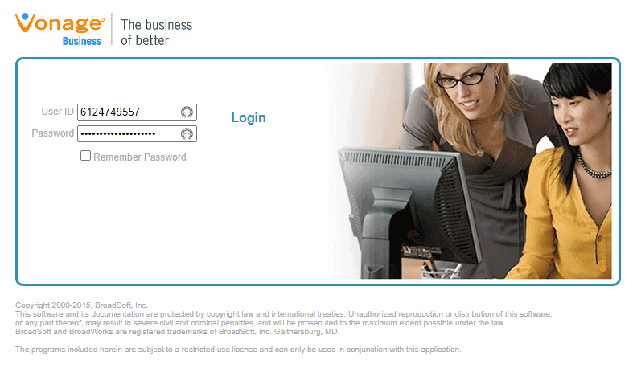
Navigate to Profile > Announcement Repository
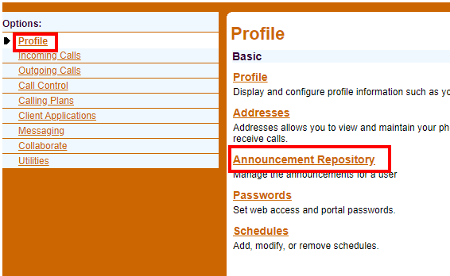
Click on Add
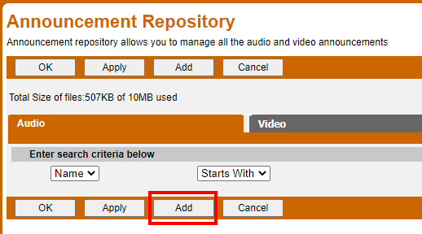
Click on Choose File
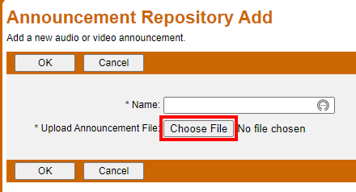
Navigate to the folder where your converted recordings were saved and open one of the recordings.
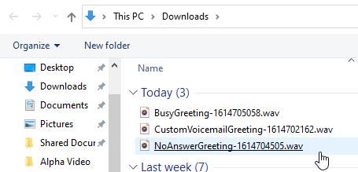
Give a meaningful name to the upload and click OK.
Repeat this process for the remaining recordings, if any.
Next, navigate to Messaging > Greetings.
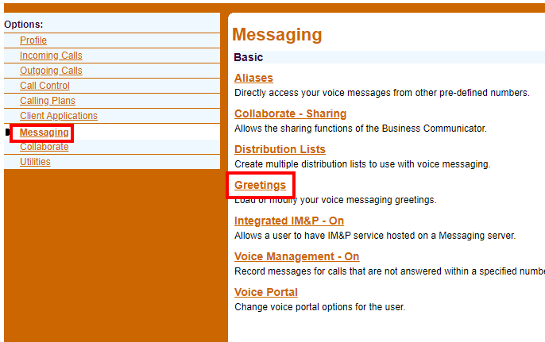
Select your personal greetings from the dropdowns and click OK.
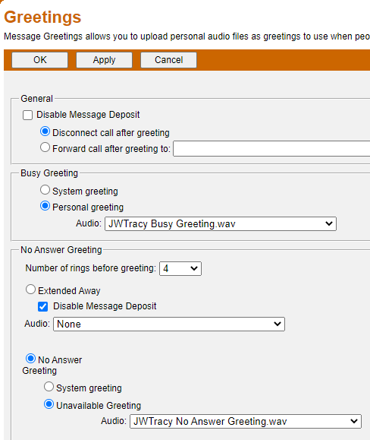

Method 2: Phone Call Recording
This is the only method that will allow the name in the standard greeting to be changed.
With your desk phone or MobileConnect application, dial *86
Enter your voicemail PIN
If you do not know your voicemail PIN, then open a ticket with the helpdesk and request and voicemail PIN reset.
Follow the automated system prompts to select your voicemail greeting configuration changes.
Selections include Configuring your busy greeting, no answer greeting, extended leave greeting, and recording your name for the standard greeting.

