MFA Authenticator App Install
Required for VPN Access

To install the required MFA authenticator app (required for VPN access), follow these steps.
Go to https://mysignins.microsoft.com/security-info and check to see if you have
Microsoft Authenticator – notification selected as your default sign-in method as shown below.
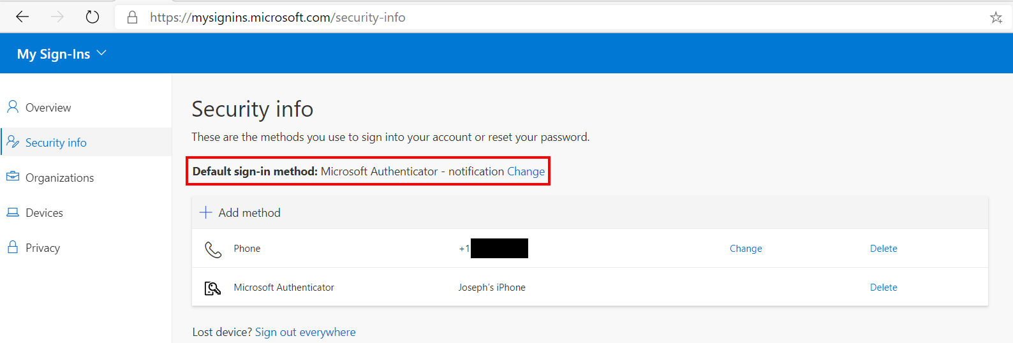
If you already have this as your default sign-in method, then you are already prepared for the VPN secondary authentication. If not, then continue along the following steps.
If you do not have the authenticator app listed as a sign-in method, then click on + Add method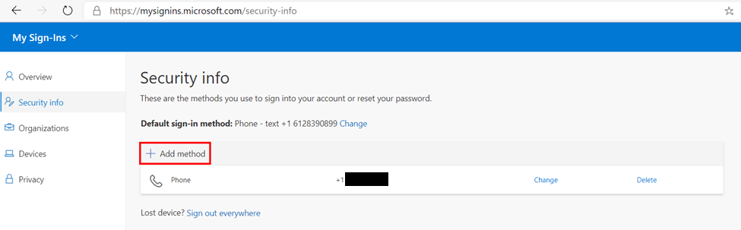
In the window that opens, select Authenticator app and click Add.
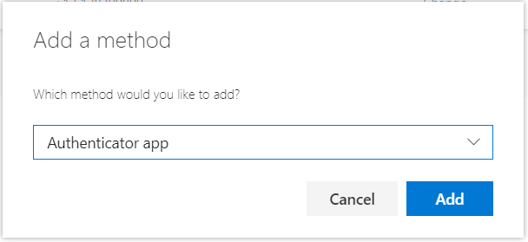
You will then be prompted to install and open the Microsoft Authenticator app on your phone.
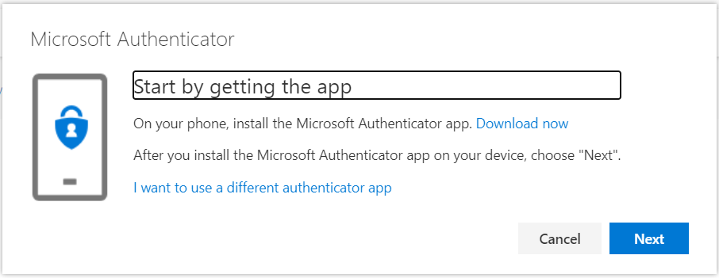
The most reliable way to get to the App Store or Google Play Store page for this app is to search for it. Do not select the option to use a different authenticator app. Other Authenticator apps will not work with the VPN.
On your phone, open the App Store or Google Play Store and search for Microsoft Authenticator.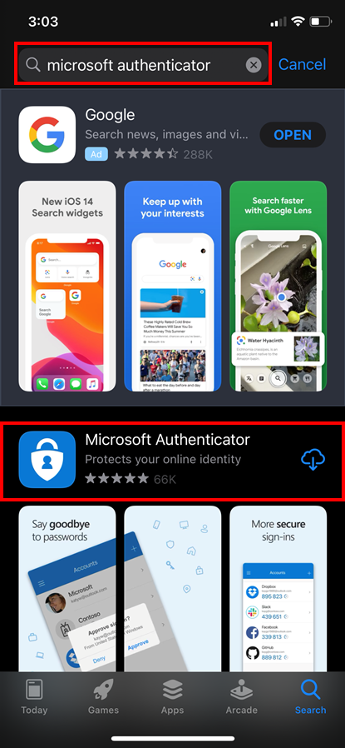 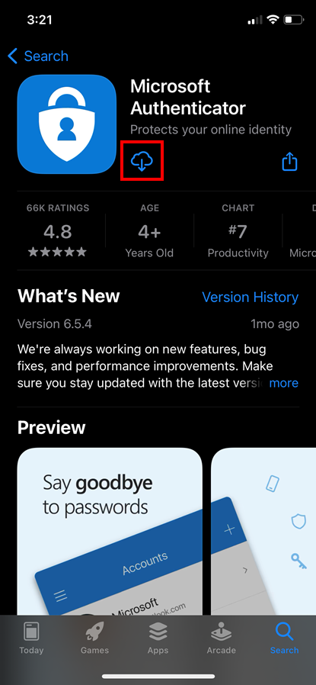
Download the app onto your phone and select Next on your workstation.
You will next need to setup your account on the authenticator app.
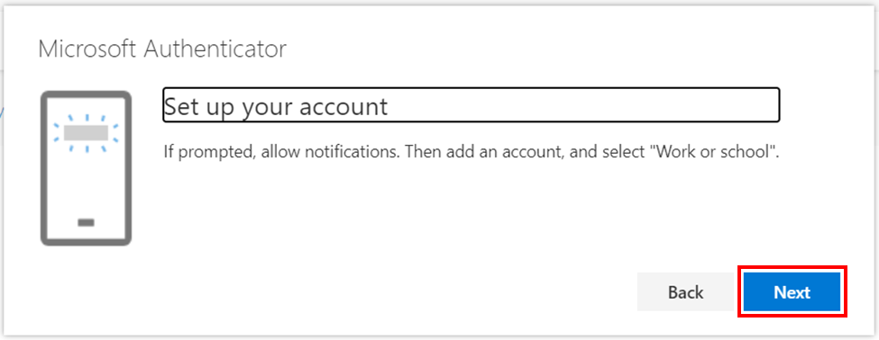
Click Next
You will next have a QR code shown to you.
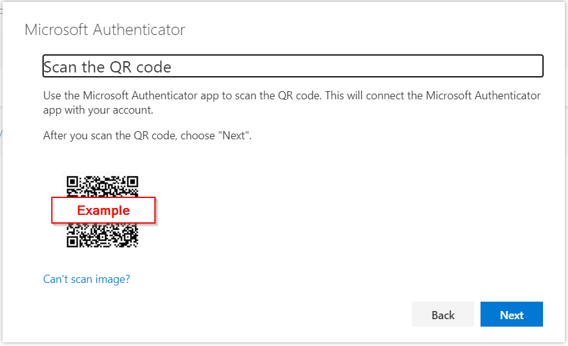
Open the Microsoft Authenticator app on your phone, accept the privacy policy, and select Scan a QR code.
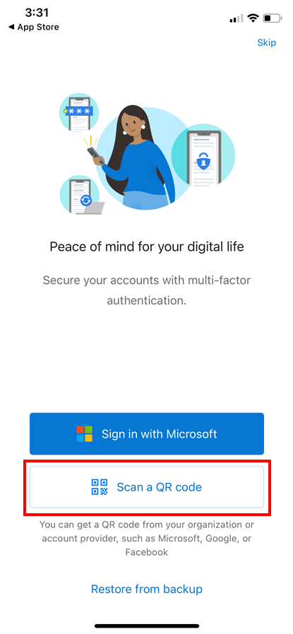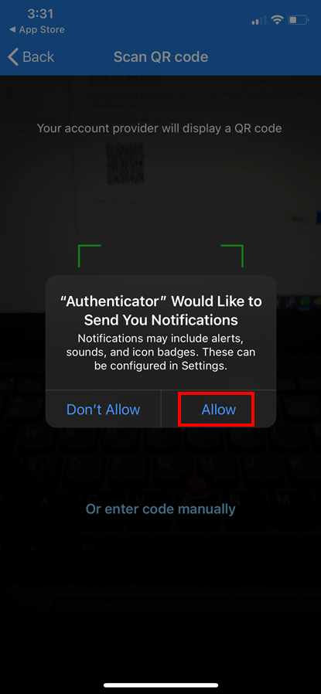
Scan the QR code on your workstation with your phone. You will then be asked if you would like the app to send you notification. Select Allow.
If your account has successfully been linked to your authenticator app, then you should see something that looks like this.
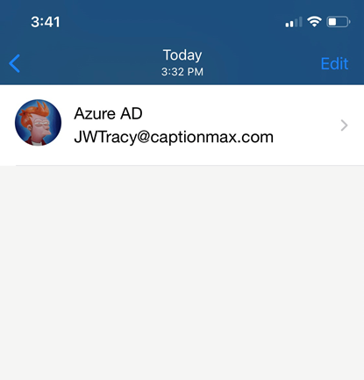
Your workstation will now send a notification to your phone requiring approval.
Approve the notification and you should see this on your workstation:
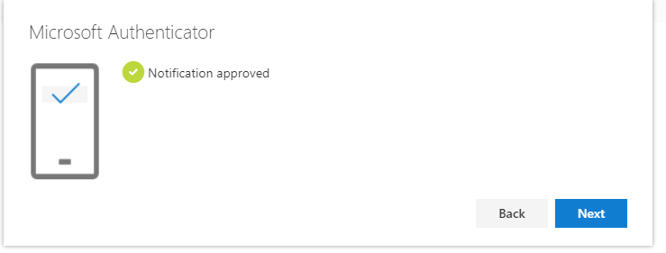
Click Next
You should now see the Microsoft Authenticator listed in your sign-in methods as depicted below.
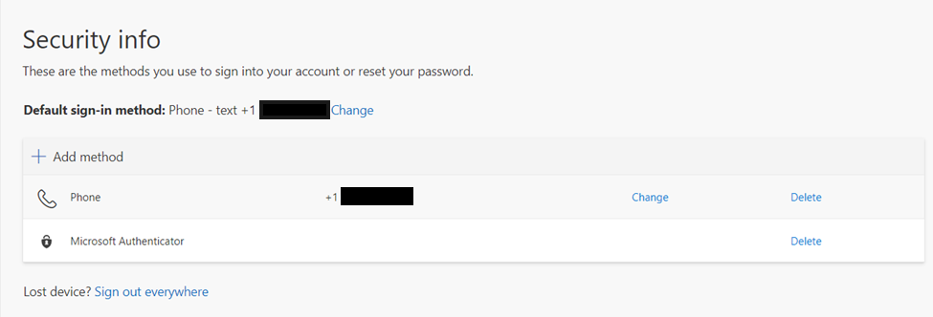
Note: The authenticator app only has access to your camera when scanning your QR code, your network connection when communicating with O365, and your notifications when requesting your confirmation of authentication. It has no access to apps, data, or any other personal information on your device.
On your workstation, under default sign-in method, click Change.
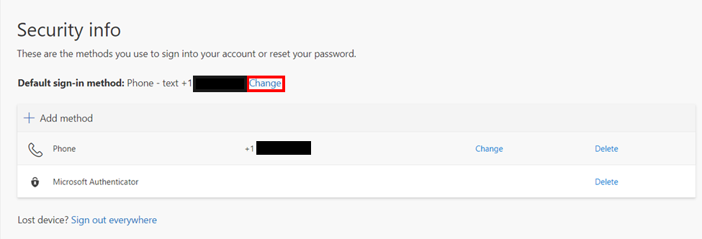
Select Microsoft Authenticator – notification from the dropdown.
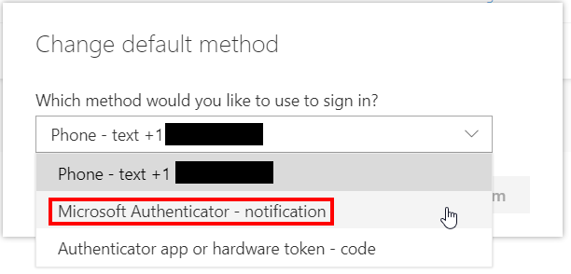
Click Confirm.
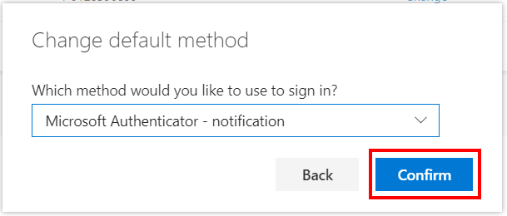
All future secondary authentication requests will now be done via app notification on your phone. When remotely signing into your account, your phone will prompt to approve or deny the login request. If your phone ever asks you to approve an authentication request that you did not make, then notify IT right away with a helpdesk ticket.

