Maas 360 iPhone Installation guide
Follow the steps below:

- Click the link from your phone or scan the QR code
- The login is you first initial and last name and the password is your email password. Then push Corporate and click continue

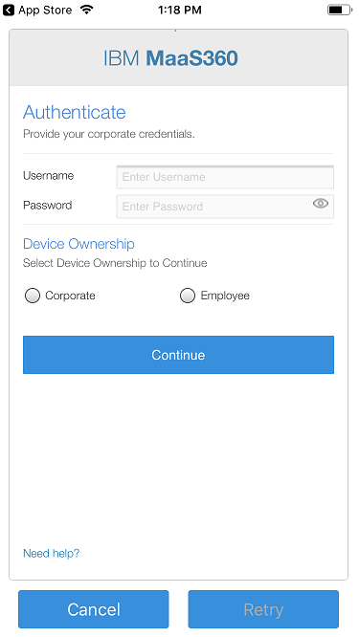

- Click Continue

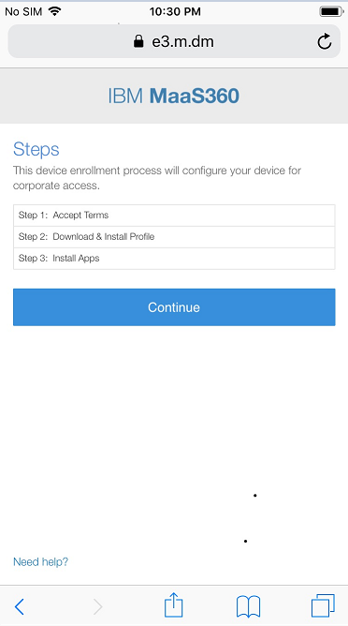

- Then Accept Terms and continue.
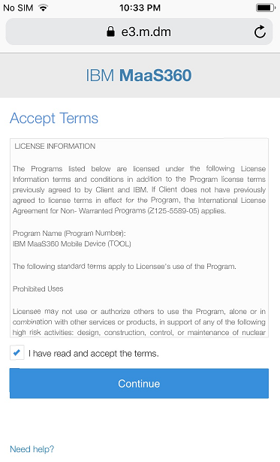

- Click Download to download the profile. You’ll receive a notification that the profile is downloaded.

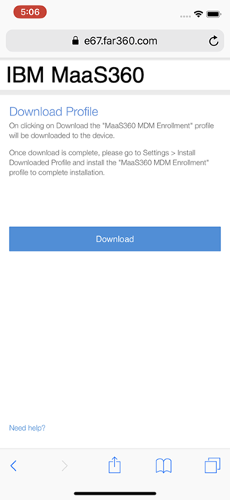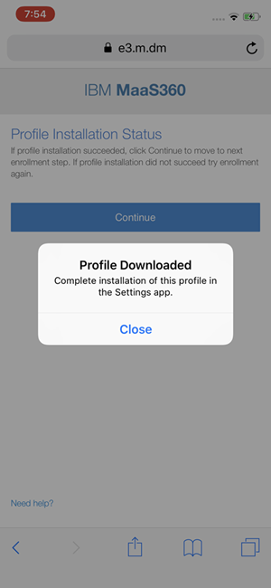

- After the Profile is downloaded, do not click continue. Click the home button. Go to the Settings App (it looks like a gear). Once in the settings app you will see Profile Downloaded. Click that. Tap install in the upper right-hand corner.
Note: The downloaded profile is automatically deleted if you do not install the profile within 8 minutes after you downloaded the profile.

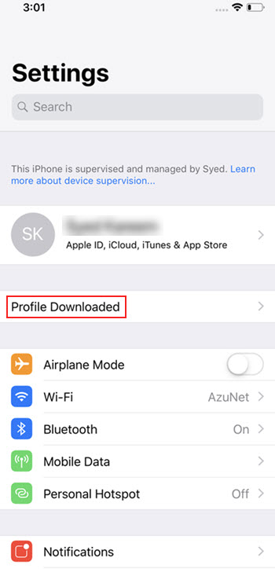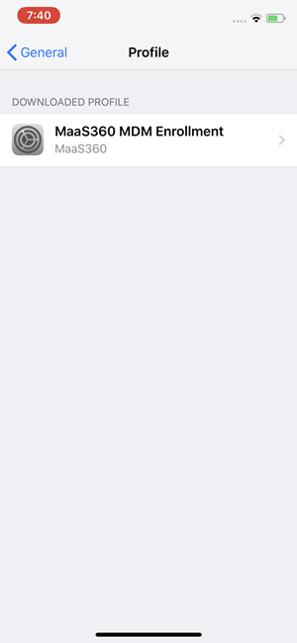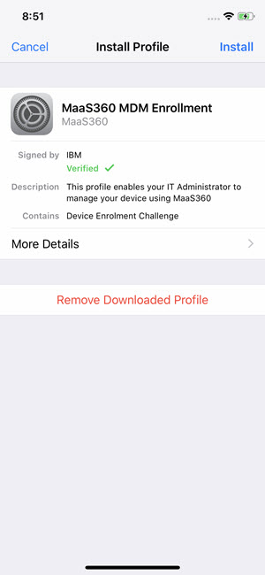

- A warning message about MaaS360 remotely managing your device to install the profile is displayed. Tap Install. Then a warning will pop up Click Trust.

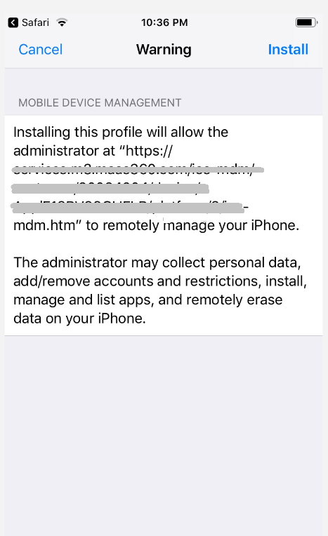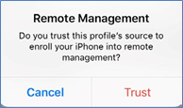

- Click the home button. Go to the Safari browser (looks like a compass) and in the Profile Download Complete screen, click Continue.

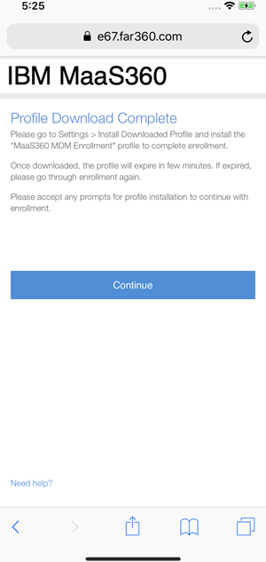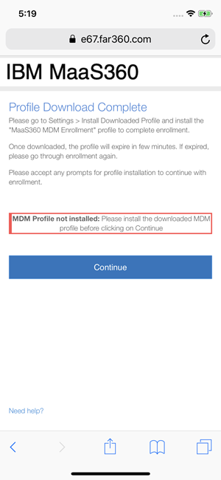

Your apps should start to download, and you are all set.

