Sophos – macOS some services not running

- Open Sophos and click on the button Run Diagnostic Tool
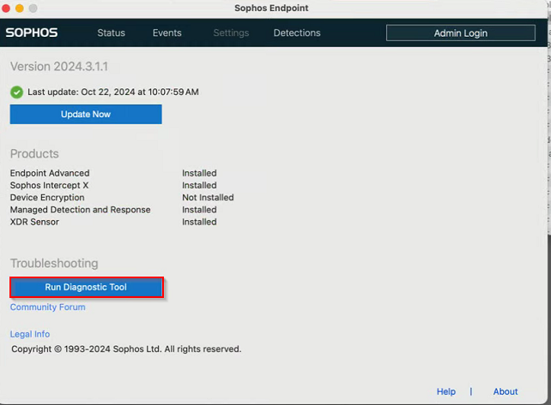
- In the Self Help windows click on the Prerequisites tab then click on the button Allow Full Disk Access
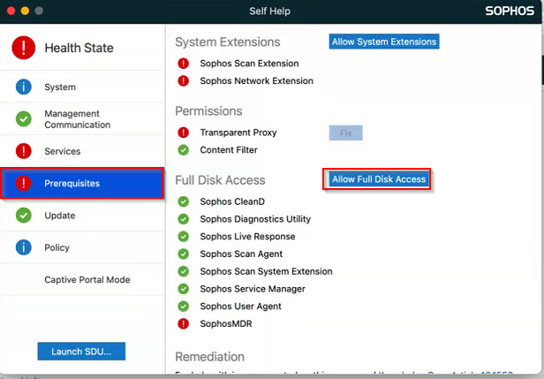
- A new windows will open and you want to click on the words Open “Privacy and Security” preferences and the System Settings will open to the Full Disk access section on the macOS
  - Then drag the Sophos icon from the Sophos Endpoint window and drag it into the Full Disk access area. Then enter local admin credentials to allow the processes to be added into the System Settings of Full Disk Access
  - Eight Sophos applications will be added to allow Sophos access to the macOS system.
  - You will need to enter local admin password then if you on Bomgar then Bomgar will stop temporarily for about ten seconds.
- Back in the Self help window click on the button Allow System Extensions
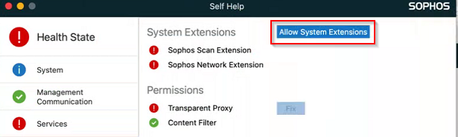
- You will be taken to Privacy & Security of the System Settings then click on the Details… button
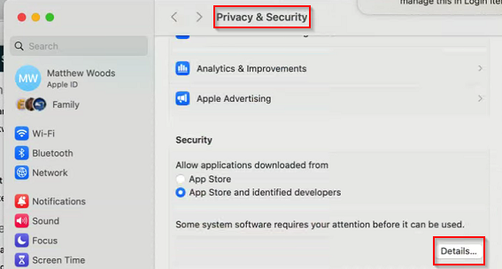
- A new window will open with the two Sophos processes Sophos Network Extension and SophosScanD. Slide the two options to the right until and they will turn on. Then press the OK button.
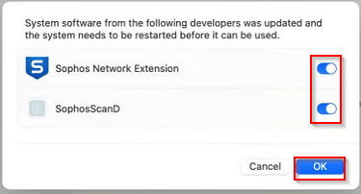
- Click on the Allow button for Sophos Network Extension. If you are on Bomgar then it will stop for about ten seconds then you will reconnect with Bomgar.
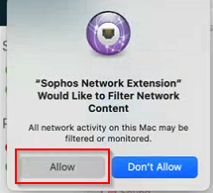
- This is how Sophos is installed on macOS.

