How to install the Ricoh Fiery Software
** The IP Address of the Ricoh 7210 machine is 10.221.70.12
- Go to the windows search bar and go to the run command
- Type in \\10.221.70.12 then press Enter
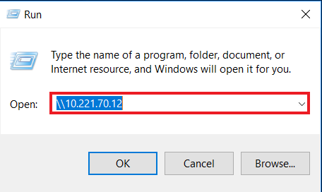
- Choose the Folder PC_User_SW for Windows
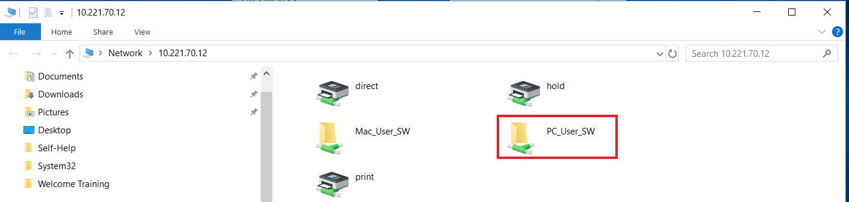
- Click on the option MasterInstaller.exe
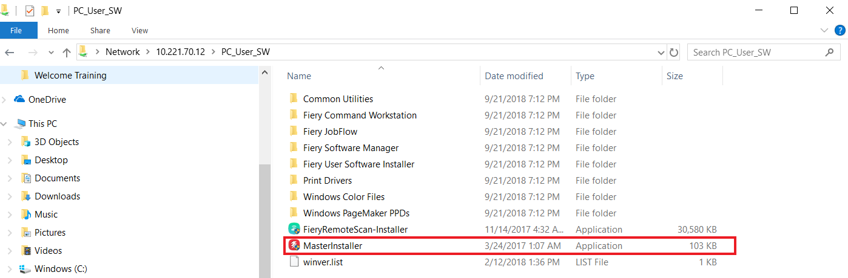
- Then choose the default options
- Once the application is installed then choose the option to restart the PC.
- Login as the user with their credentials and open the Fiery Command Workstation
- Once the Fiery Command Workstation is open click on plus button (+) Add your first Fiery server
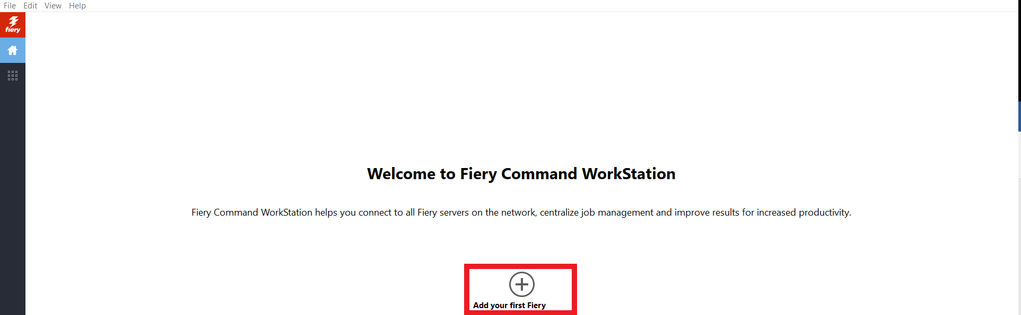
- Then enter the IP Address of the Fiery Server then click on the Add button
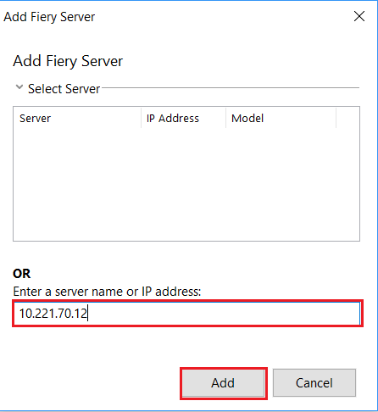
- The admin credentials should pop up and make sure the Save Password is checked then press the Login button.
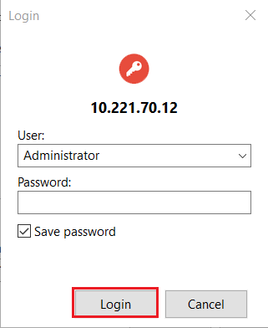
  - There is no password for the Administrator account.
- The jobs should load from the Fiery server. Done.
***Published on 4/15/2019 by Michael LaMantia

