Manually pull down the SAUSC_THQTrusted Certificate

- Go to the Windows PowerShell and type mmc.exe. A new box should appear in the Microsoft Management Console.
- Go to File and Add|Remove Snap-in
- Go to Certificates and click on the Add Button
- Select and choose My user account and Finish then OK
- Delete any iPhone certificates that are showing in the Issued By section
- Expand Certificates- Current User field, then expand Personal folder that will show Certificates folder.
  - Right Click on the Certificates folder and select All Tasks and choose the option Request New Certificate
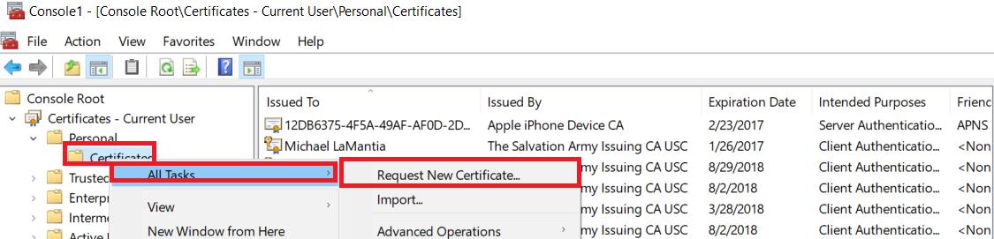
  - Click the Next Button
  - Click the Next button again
- Check the box Policy User01 and make sure the box is checked. Then click on the Enroll button
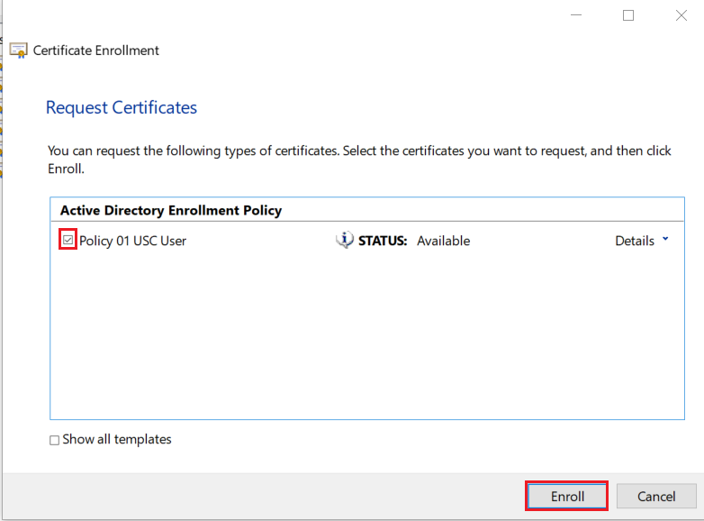

- The certificate should start to download and then say it was successful once the certificate has been added.
- In the Microsoft Management Console go File – Save As
- Then click on the button that says Save. Say yes to overwrite the file.
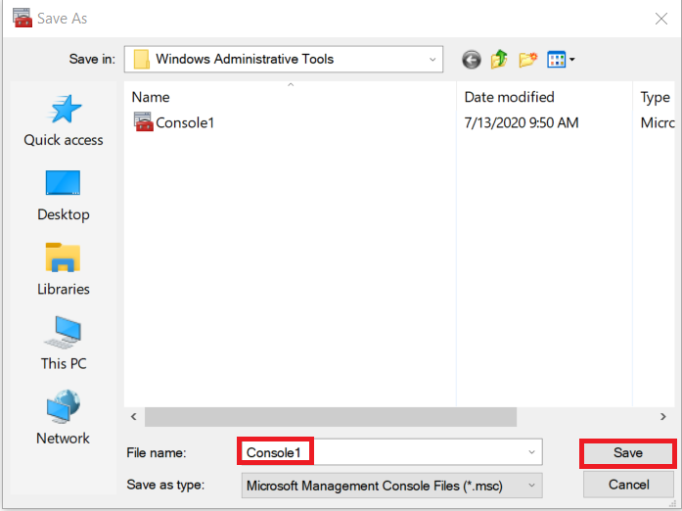
- Make sure the PC has an Ethernet connection. It may take five minutes for the new certificate to work on the SAUSC_THQTrusted network.

