How to install Dataloader on a Mac (M series chips)

Install Dataloader on Mac (M series chip)

1) Go to Azul and choose macOS x86 64-bit
https://www.azul.com/downloads/?version=java-11-lts&os=macos&architecture=x86-64-bit&package=jdk
2) Install the dmg file on the Mac
3) Open the terminal prompt and type the following command below in the terminal
/usr/sbin/softwareupdate --install-rosetta

https://developer.salesforce.com/docs/atlas.en-us.dataLoader.meta/dataLoader/loader_install_mac.htm

4) Once typed in the terminal prompt put in the following letter: A
5) The rosetta should finish installing
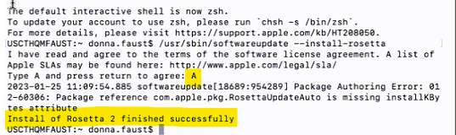

6) Run the installer.commnad from the Zulu folder
7) Specify where you want the Zulu folder installed. I recommend the Documents folder
a) Create a folder called Dataloader in the Documents folder
8) Once it specifies a path go the Apple menu View > Show Path Bar
https://support.apple.com/guide/mac-help/get-file-folder-and-disk-information-on-mac-mchlp1774/mac#:~:text=Copy%20a%20folder's%20pathname%3A%20Control,Copy%20%E2%80%9Cfolder%E2%80%9D%20as%20Pathname.

9) In the path bar press control on the Mac or Windows PC and right on the new Dataloader folder in the path then choose Copy Dataloader as Pathname
10) Paste it into the new terminal prompt. It should show the path and press Enter
11) The installation of the Dataloader should start and then type Y or Yes for desktop and/or launch icon
12) Once Dataloader installation is complete run the Dataloader icon on the desktop to make sure that it opens.

