How to include non-Army (or even other territory) people into your Teams chats, or video chats.

You CAN have typed chats and video chats in Teams with people who are not in our organization!
1. Either create a new Team specifically for this chat, special group etc…
OR add your “outside” people to an existing Team.
2. To add an external e-mail address as a member of a NEW Team:
Open Teams
Create a new Team by clicking the Join or Create Team button on the bottom left of your screen

Click on Create Team
Click on “From Scratch”
You will probably want to choose Private, but you can choose Public (which means people can
join without asking your permission)
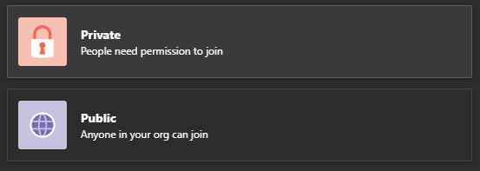

Name your Team. (there are literally thousands of Teams already created in our Territory. Many
will have very similar names. Be certain your name is immediately recognizable to your target audience)
As you add Team members, the Army Global Address List will be used. For “outside” Team members enter their FULL e-mail address ie: johntate@gmail.com or john.tate@uss.salvationarmy.org
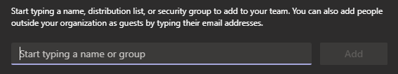
3. To add an external e-mail address as a member of an EXISTING Team:
Open Teams
Enter the existing Team you wish to add members to
Click on the ellipsis to the right of that Team
Click on Manage Team
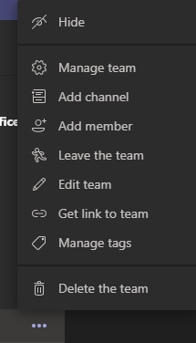
Click on Add Members


s you add Team members, the Army Global Address List will be used. For “outside” Team members enter their FULL e-mail address ie: johntate@gmail.com or john.tate@uss.salvationarmy.org

4. What happens when you invite an “outside” member to join your Team?
When you add an “outside” e-mail address to the members of your Team,
the invited person receives an e-mail at the address you entered:
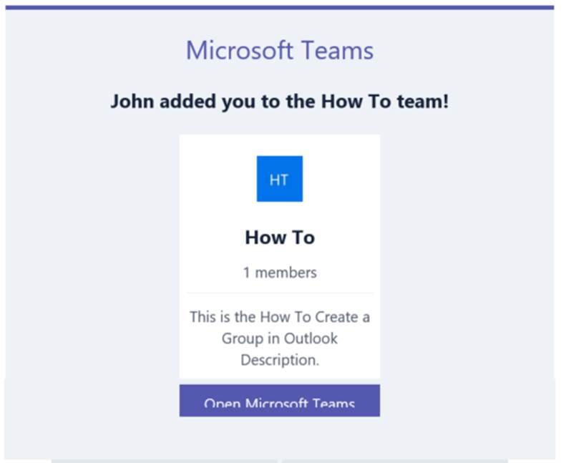
When the user click on Open Microsoft Teams they can click on “Use the Web App”
to be connected to the Team even if they do not have the O365 software.
It will prompt them to use the e-mail address you entered as their user name.
It will prompt them to create a password to use to access Teams.
That outside person will now have Teams in the same way that YOU have Teams.
Any Teams thread conversations, chats, video chats, file sharing etc is now accessible to your
outside member.
5. What happens if an outside member forgets the password to their Teams account?
Whenever an outside user is prompted to sign into Teams, they are presented with a “Forgot Password” button. If they press this button it will send a reset password option to the e-mail address we used to add them as a member.
If you have any questions do not hesitate to contact me:

John E. Tate IV
IT Help Desk Coordinator
The Salvation Army
Central Territorial Headquarters
5550 Prairie Stone Parkway
Hoffman Estates, IL 60192
847.294.2030
847.227.5030 (f)
www.salvationarmy.org

