How to use PDF 995
What is PDF995?
- PDF995 is a program that let’s you combine and extract PDFs. All PCs come with PDF995 installed on them.

Where to find PDF995?
- Go to the Start button on your computer and type pdfedit. An result should appear and click on the following option pointed below on the screen. Pdfedit995 is the program within PDF995 that allows you to rotate, combine, and split PDFs
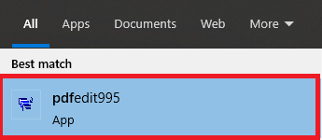
How to use PDF995
- Once you have chosen pdfedit995a pop up will appear and click on the option Continue using the sponsored version.
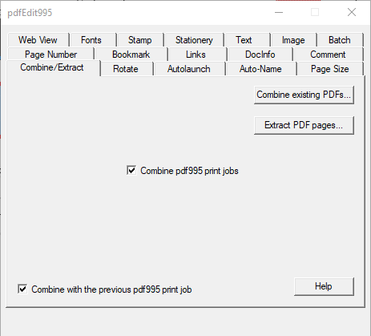
- You should see the following text box below

How to Combine PDFs
- Once pdfEdit is open choose the tab Combine/Extract
- Click on the button Combine existing PDFs…
- A new text box will open saying Combine PDFs
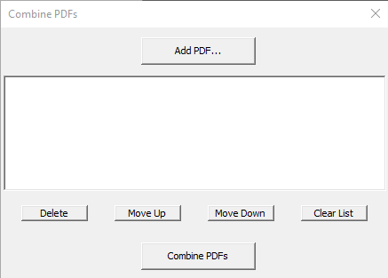
- Choose the option to Add PDF. This will allow you to select one of the many PDFs that you want to combine.
- Then repeat the process for the other PDFs that you want to combine
- The PDFs will combine from a top to bottom order
- Once you have selected the PDFs that you want to combine into one PDF click on the button Combine PDFs
- Once you click the button Combine PDFs you will have to name the new PDF that has all combined PDFs into the new one PDF.
- Once you have saved the PDF your new combined PDF is now ready

What is Extract PDF?
- Extract PDF allows you to take pages out of a PDF creating a new PDF with the pages that you have taken out of the original PDF.

How to Extract PDFs
- Once pdfEdit is open choose the tab Combine/Extract
- Click on the button Extract PDF pages…
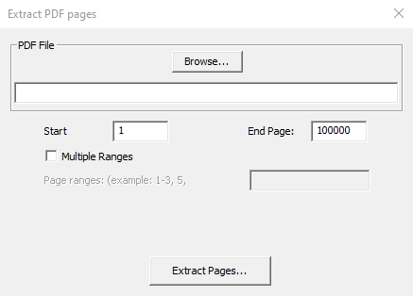
- A new text box will open saying Extract PDF pages

- Click the Browse button to select a PDF that you want the pages extracted out of.
- Once the PDF is selected go to the Start section and type the page number that you want the first page that you want to extract out of the PDF. (Ex: 5)
- Next, go to the End Page: and type the last page you want extracted out of the PDF (Ex: 20)
- Click on the Extract Pages… button this will create a new PDF with the extracted pages once file has been named.
- Multiple Ranges allows you select certain pages to extract out rather than whole sections.

