TEAMS – OUT TO LEAVE/PERMIT YOUR TEAMS MEETING PARTICIPANTS PAST THE LOBBY
- Open Teams
- Open the Calendar
- Create a New Meeting
- Invite Participants / Send Invitation
- On your Calendar Open that event
- Click on Meeting Options
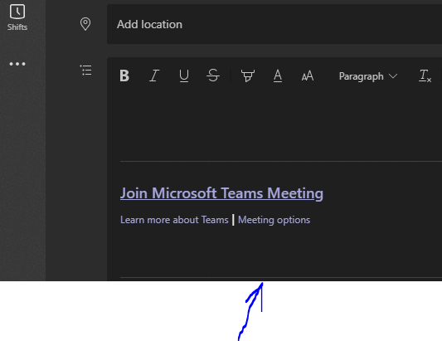

- Set the Always let participants bypass the lobby to “NO” if you want them to wait in the lobby
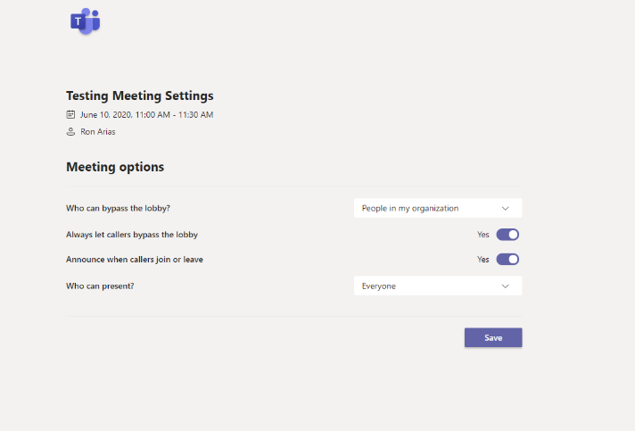
When you set to NO every person in waiting in the lobby will prompt the meeting owner
to be let into the meeting.
- Save.

