Outlook
Granting Access to your Outlook Calendar
4.26.21 (Windows Only)

- Open Outlook
- Open the Calendar
- Go to My Calendars section, right click on your calendar, and choose Sharing Permissions
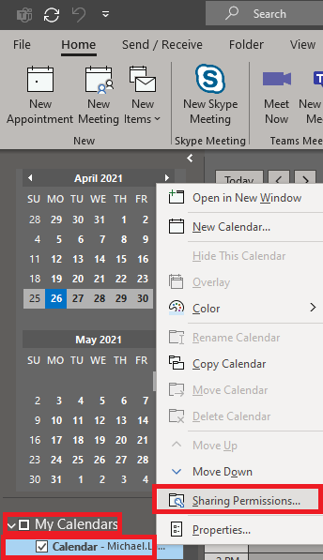
- Go the Permissions tab and Click on “Add” button
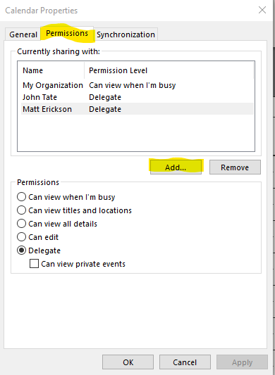
- From the Army Address Book, Choose the name of the person you wish to grant access to.
- Set the permissions to what you would like them to have.
- Click Ok.

The Person you granted access to will now have YOUR name listed in THEIR Outlook.
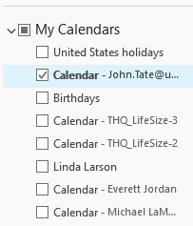
Your Calendar will not display for them unless they check-box your name.

If your calendar doesn’t show up in the person’s calendar in Outlook that you granted access to after 24 hours. Here is how to manually add your calendar.
- Go the user’s calendar you have granted access to your calendar
- Go to the Home tab – Add Calendar – From Address Book
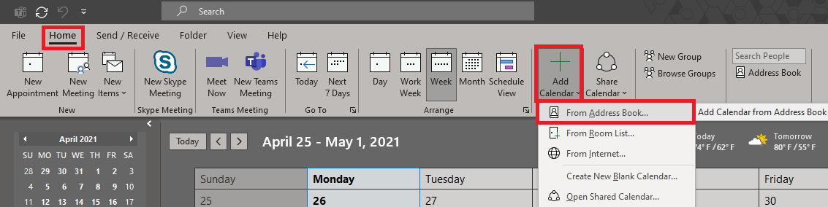
- Select your name of the Address Book and it now should appear in their Calendar. Make sure the box is checked so that he/she can see your Calendar in their Outlook calendar

