Outlook
Sharing your Personal Calendar
6.4.20

- Open Outlook
- Open the Calendar
- Click on Share Calendar
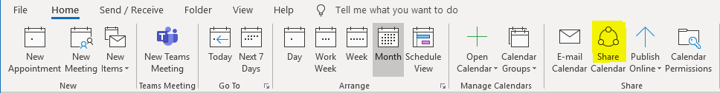
- An e-mail will open.
- Address the e-mail to those you wish to Share your Calendar with
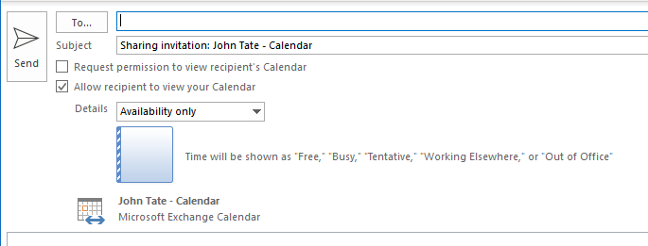

THIS DOES NOT GRANT THEM ACCESS TO MAKE CHANGES TO YOUR CALENDAR.
If you need to do this see another document called “Granting Access to your Outlook Calendar”

