Giving someone else access to your Outlook Folders

- The Person Granting Access
  - On your Computer, in Outlook
  - Right Click on your Name (Above your Inbox)
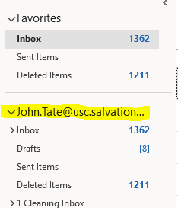
  - Choose Folder Permissions
  - On the Permissions Tab – Click Add and select the name from the Global Address List
of a person you want to grant access to
  - Set the Permissions to AUTHOR.
  - Click Ok
  - Locate a folder you wish to grant this person to have access to
  - Right click on that folder and choose Folder Permissions
  - On the Permissions Tab – Click Add and select the name from the Global Address List
of a person you want to grant access to
  - Set the Permissions you desire the person to have
  - Click Ok

- The Person Receiving Access
  - On your Computer, in Outlook
  - Right Click on your Name (Above your Inbox)
  - Choose Folder Permissions
  - On the General Tab – Click Advanced
  - Click on the Advanced Tab
  - Click on the Add button
  - Select the Name of the person’s mail file you want to have displayed beneath your inbox
  - Click OK
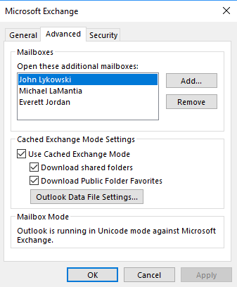
  - Now, beneath YOUR Name, this person’s name and a list of folder you have been granted access to will display:

