What is a File Path?

A file path is a specific location of where a file has been stored.
Here is a good example of what a file path looks like:
C:\Users\john.tate\Pictures\Army Shield.png

On any given computer there can be trillions of locations where a file might be stored. At some point you may need to find that file so that you can read it, share it with someone else, e-mail it to someone else, or maybe even delete it. But what if you cannot find it? How will you attach it to an e-mail if you cannot find it? There are a few things we can do to help us remember where files are stored.
- Use a Bookmark
- Save as a Favorite
- Create a logical file structure
- Keep a journal
- Footnote the File Path
- Use a search field

Today we are going to talk about #3 and #5 above!
#3 Create a logical file structure
When managing your computer’s hard drive, the best practice is keep all of your files organized in a logical way. “What is a file?” Great question! Essentially EVERY single thing on your computer is saved in some sort of file. The types of files you are probably most familiar with are:
.docx
.xlsx
.jpg
.exe
and this guy  which we simply call a “file folder”
Here is great example of well organized files:
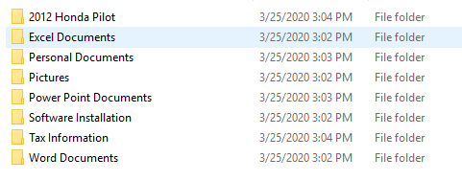

The first thing you will notice is that there are no rogue files in this list. All items pertaining to my car are in the 2012 Honda Pilot folder. All pf my pictures are in the Pictures folder. All of my Excel files are in the Excel Documents folder etc… There aren’t any random files hanging around that have not been properly filed.
Keeping the right files in the right folders will enable to locate a file you need easily and quickly.
Be diligent about not filing a PowerPoint file in with your pictures!
Become even more granular in your filing method! Create sub folders that separate like-pictures.
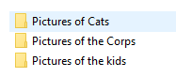

#5 Footnote the File Path
Often, you may need to print out a document for distribution. Or e-mail it to people who do not have access to the file path that you have the document saved under (Like your C: Drive). Someone may hand you a print-out of your document or refer to an e-mail you sent them your document in. They may say “can you change this part? Or can you update this figure?”
OH! Now I need to remember where I stored that file!! One of the best favors you can ever do for yourself is to write in a footnote of the file path where that document is stored – ON EVERYTHING YOU CREATE. A perfect example would be:
C:\Users\john.tate\Pictures\Army Shield.png (Last Modified by John Tate 3.25.20)
This should be the very last thing in your document and it should be at the very bottom of the page.
This file path explains where the document is stored, what the name of the file is, who updated it and when. The only thing this file path does not reveal is the exact computer the file is located on.
More than likely, based on the information above, the file exists on John Tate’s computer.
On John Tate’s computer you would open Windows Explorer
Click on the C Drive
Click on the folder called Users
Click on John Tate
Click on Pictures
In the Pictures folder you should see the file called “Army Shield.png”

Can you see how the file path tells you where to click?
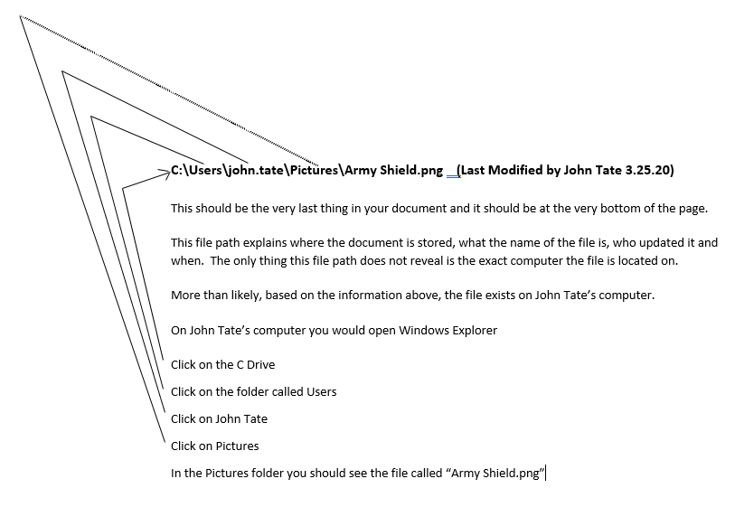

Hopefully you now have a better understanding of what a file path is and how to use it!
If you need further information do not hesitate to contact the Help Desk!

