How to install DataLoader for CRD Department
- Go to the following website:
https://developer.salesforce.com/docs/atlas.en-us.dataLoader.meta/dataLoader/loader_install_windows.htm

- Scroll down to the first instruction where it says Install Zulu OpenJDK version 11 for Windows using the MSI file and click on the blue words for Windows
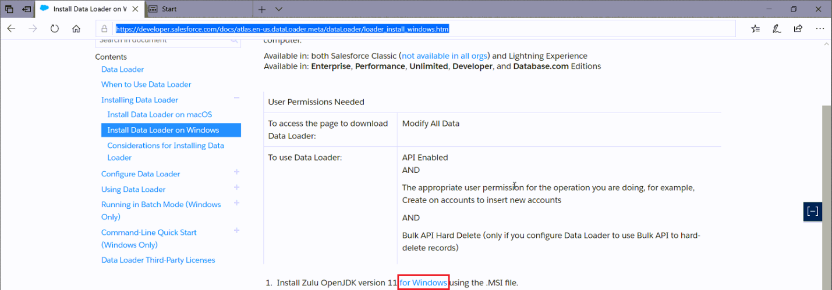
  - You will be taken to a new page called Azul Systems.
  - Next, narrow your search results for Zulu Community Downloads
    - Java Version: Java 11 or if they are recommending a newer version from the previous page
    - Operating System: Windows
    - Architecture: x86 64-bit
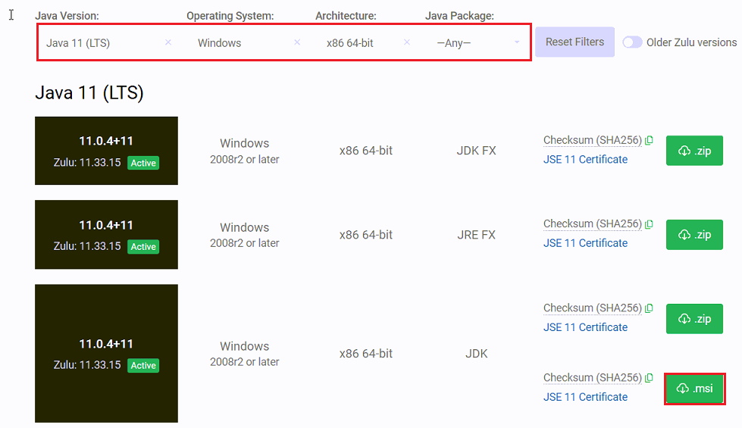
    - Java Package: Any

  - Click on the option for the MSI file and once the file is downloaded, right click on the msi file and run as different user
    - Enter the local admin credentials
  - Once the Zulu MSI file has been downloaded from the website, double click on the file to install the program. Enter admin credentials to install the program.
- Create a new folder in the root of C: called Zulu (C:\Zulu)
- Put the Dataloader.zip file onto the user’s desktop and right click and choose option Extract All
- Extract the Dataloader files into the Zulu folder under C:\Zulu
  - Michael has a copy of the Dataloader zip file if you can’t find it.
- Next, right click on the dataloader Batch File and choose the option to create a shortcut to the Desktop.
- Double click on the dataloader and it should bring the Salesforce Dataloader
