 | 02. Message Protection Procedure
Audience |  | All Territorial IT Administrators  All Territorial Leaders
Author |  | IT Council
Owner |  | IMC
Version |  | 1.0
Published |  | 10 August 2019
Review

Version Control
Ver | Date | Comments
0.2
0.1 | 22 October 2018 | Initial version

Published History
Ver | Published Date | Published By

Introduction
The Salvation Army has historically used IBM Notes encryption to protect highly confidential emails. Office 365 has a different implementation to protect messages and provide encryption. This document discusses the scenarios in which the Army may need to use some type of message protection.

Encryption Scenarios
Your message in Office 365 Outlook is transmitted and stored securely to other Office 365 users. Encryption is not normally needed unless the message falls within the following scenarios:
- Message unreadable by anyone except the recipient(s) including the assistant
- Privileged legal information unreadable by anyone except the recipient(s)
- Message must not be copied, printed or forwarded
- Some individuals (internal or external) may require all messages to be encrypted during transport
- Subject access request (GDPR and e-discovery) for information surfaces encrypted messages

It is anticipated that these scenarios will exist for internal and external recipients when sending emails of a private nature or where the attachment needs to be protected.

Data Loss Protection
Office 365 offers services to assist in complying with privacy laws that many countries have passed. One such example is the GDPR legislation that applies to all member states of the EU. Part of complying with these laws is being able to dispose of information related to a person.
DLP (Data Lass Prevention) policies allow us to identify common personally identifiable information – driver license, passport, etc – and other sensitive information - social security numbers, credit card, etc – then act upon it. With the correct license, information can be automatically categorised to ensure compliance with legislation we are aware of.
Currently the GLOBAL tenant identifies some of the abovementioned types of information in email messages and warns the sender. This is deliberate as we navigate our way in a new operating environment with compliance requirements like GDPR.

Technical Solution
Outlook provides out-of-the-box options for message protection. The default options are:
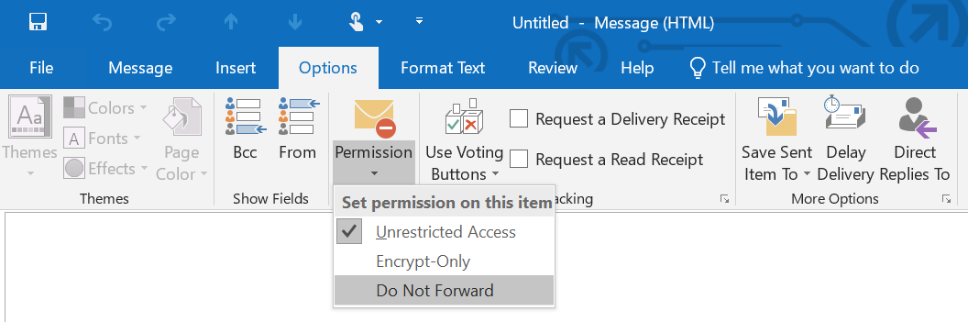

Protection for each of our scenarios are as follows:
- Message unreadable by anyone except the recipient(s) including the assistant
Select Encrypt-Only as permission
- Privileged legal information unreadable by anyone except the recipient(s)
Set Do Not Forward as permission on message
- Message must not be copied, printed or forwarded
Select Do Not Forward as permission on message
- Some individuals (internal or external) may require all messages to be encrypted during transport
Select Encrypt-only as permission on message
- Subject access request (GDPR and e-discovery) for information
This scenario does not require permissions, rather it is one where protected message may need to be discovered as part of a GDPR information request.

