GoToMyPC instructions for remote computer access
Firstly, you need to ensure that the GoToMyPC software is installed on the office computer that you want to access remotely. If it is installed you will see an icon like this in the system tray (lower-right hand corner of your screen, next to the date and time). If you don’t see this icon pls reach out to us, we can install the software in less than five minutes.

Important Note: To access your office computer remotely you need to leave it powered on. It can be in sleep mode and/or logged out, but it needs to be powered on.

To access your office PC remotely, open any browser and navigate to:

https://www.gotomypc.com/members/login.tmpl

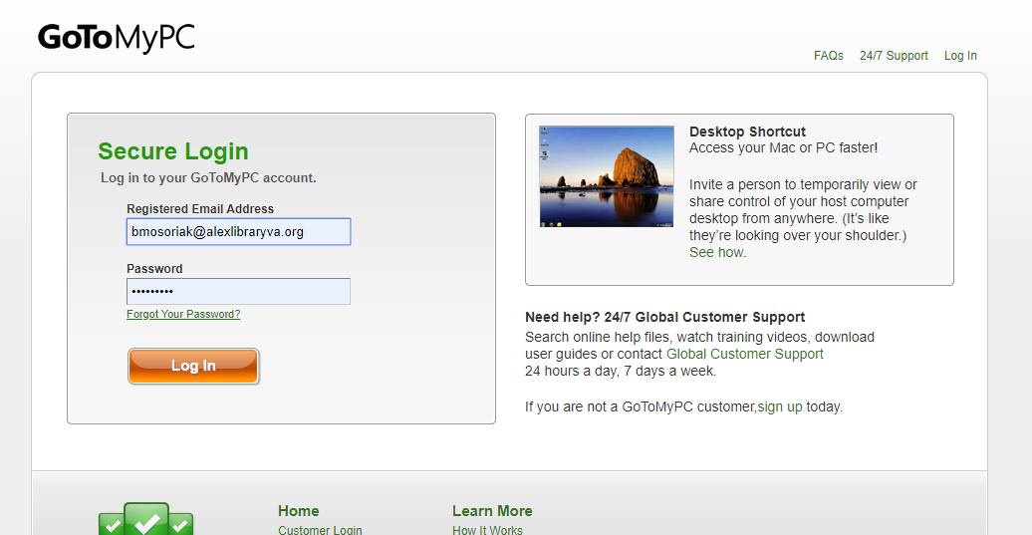

You’ll be prompted to enter your Library email address and password that you set up for your GoToMyPC account.

After logging in you’ll be taken to the following screen, select the ‘Connect’ button in the Computer List.

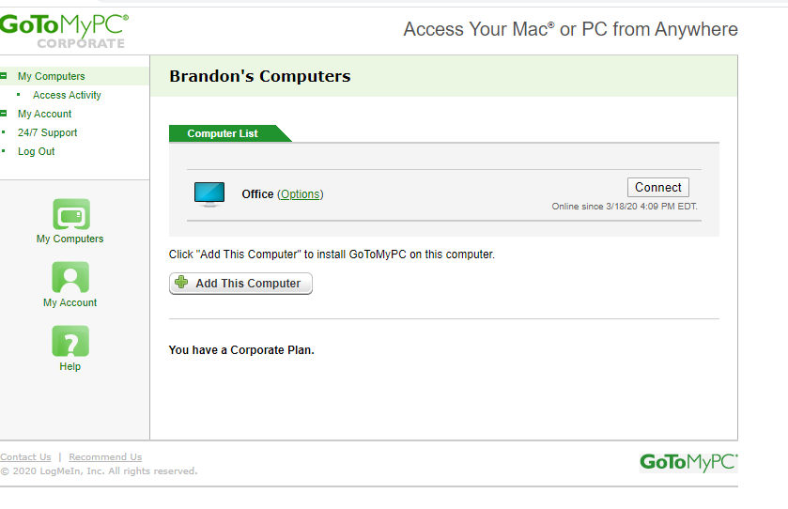

You’ll be prompted to open GoTo Opener, please do so:

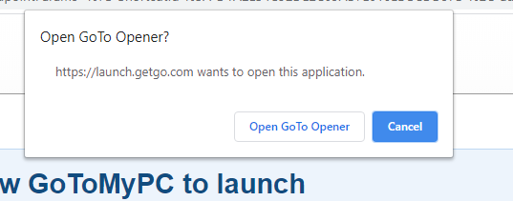

Finally, you’ll be asked to enter the access code you created when you added this computer to your account. Note: The access code is different than the password you use to log into your GoToMyPC account.

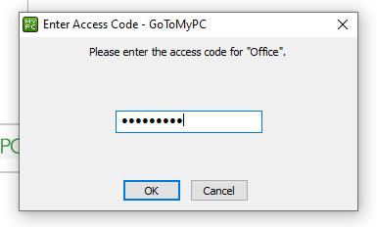

To close out to remote session, you can simply hit the X in the upper-right hand corner of the GoToMyPC software window or choose ‘Disconnect…’ from the File menu.

If you have any questions please feel free to reach out.

