Cayzu Help Desk Training

Here is the portal for the new help desk system. If you need assistance adding a shortcut for this system to your desktop please contact Library IT.

https://alexlibraryva.cayzu.com/

To submit a new request, click on the ‘Submit a Request’ button in the upper right-hand corner:

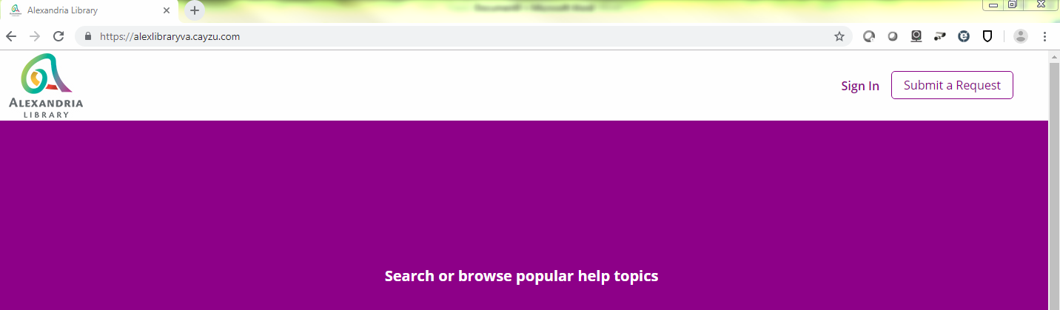
You will be asked to sign in:

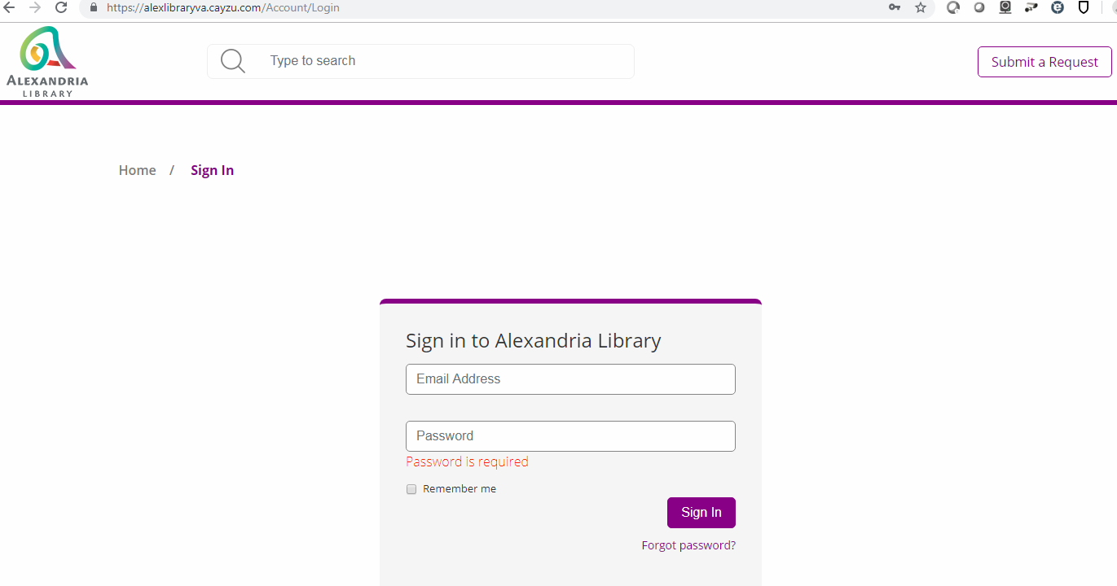

After signing in, complete the required fields and click on the ‘Submit’ button.

To check on the status of a request you’ve opened click on the ‘My Tickets’ link in the upper right-hand corner of the screen.

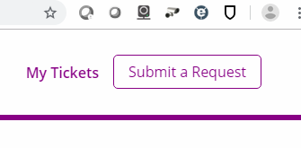
As in the current Help Desk system, you will receive email notifications when tickets are opened/closed, etc.

If you have any questions please feel free to reach out to Library IT.

